**Hints for slides preparations**

16 July 2024 (last edited: 22 July 2024, 17 Dec 2024, 2Jan2025, 4 Feb 2025, 10 Feb 2025), Chng Eng Siong

Dear Students, heres some examples of what I think slides should look like when you are presenting for PhD or discussion meetings where the focus is to communicate understandings in high level and not about detailed information. I broke down on types of slides you will need:

1. Overview techniques
2. Detailed techniques
3. Literature survey
4. Comparison of results
5. Introducing your Pipeline
6. Text-only slides
7. Introduction to objective and future works
8. Presenting to the team paper review
9. Posters - examples

You will notice that the slides being described would be figure heavy. Some comments from Jiq Qi about why figures are important.

Yip Jiq Qi: “I think for fresh phd students, it is also important to highlight to them how important images are. A new phd student might not know that often times a paper lives and dies by its figures.  **Incorporate good composition principles.** Composition is a related and very important. i try to compose nice figures in my work, but it actually requires alot of effort and its a skill that i'm still developing. There's guides like this one i just googled that can help: <https://mcmanuslab.ucsf.edu/sites/mcmanuslab.ucsf.edu/files/event/file-attachments/design-tips-scientistsguide.pdf>. Photos, artwork, advertisements, posters, all forms of visual communication need good composition to be readable to human beings. The art of composition is the study of how the human brain processes information, and there are some general principles to be followed to make any figure look good. It shouldn't be dismissed as just aesthetics, I think its part of good communication. “

**The year of ChatGPT-o (2024):** You can also use ChatGPT to create slides for you as well as structure!

See: <https://www.youtube.com/watch?v=_9pKAG_XabM>

**Note: Please remember to include citations and reference to figures/tables/information used.**

# Overview techniques.

The overview slides should have information such as: Title, objectives, purposes, citations, input->output, individual blocks. The following 3 examples show what you will need to overview techniques described.

“Overview images are for people to intuitively understand what you are going to talk about. It should be light on details and quickly communicate the concept. These are the "hero" images for the first page of a paper to draw people's attention and help put them in the right frame of mind to read the paper. It works for presentations too. It does not need to fully capture every detail of your contribution; it is just a hook to get attention. “ – Yip Qia Ji

Fig 1a. This famous Whisper slide shows the big picture of whisper architecture,   
the tasks that Whisper can perform (left window), the details of the prompt and   
output (bottom window).

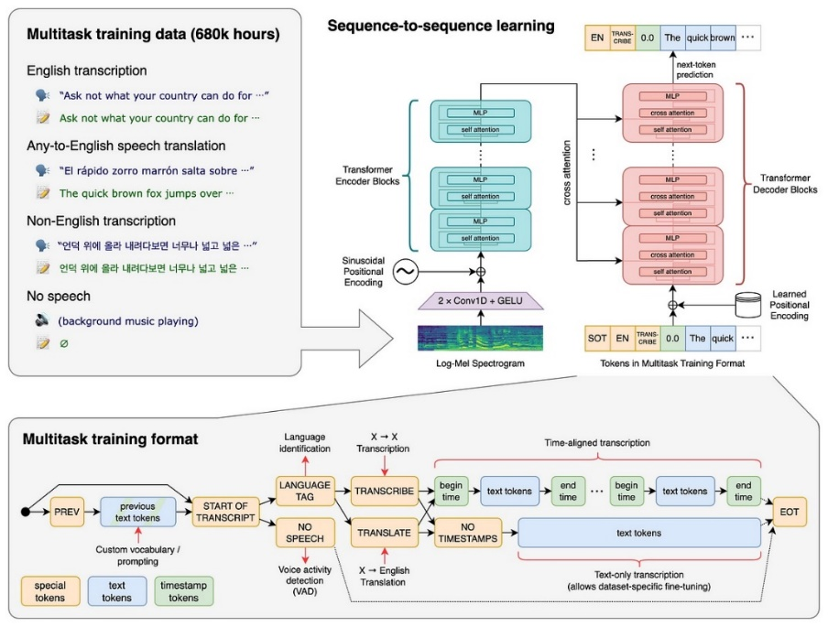

1b. Fig below shows overview of TTS, the clear breakdown of alternatives of acoustic models, vocoders highlight different approaches within each block

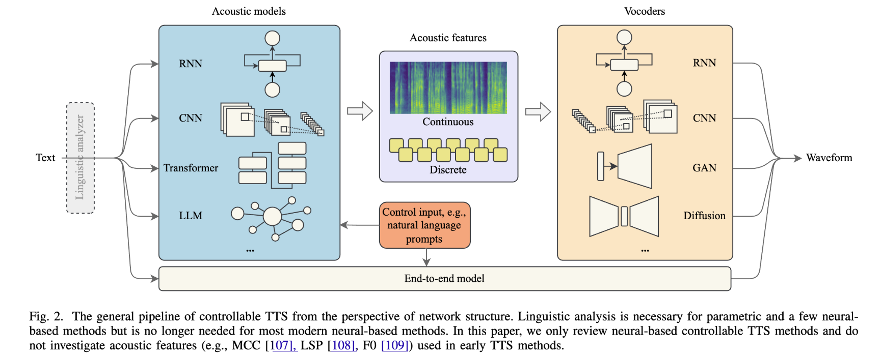

1c. Figure below shows a clear title, short description, citation,   
and input->output through pipeline towards output

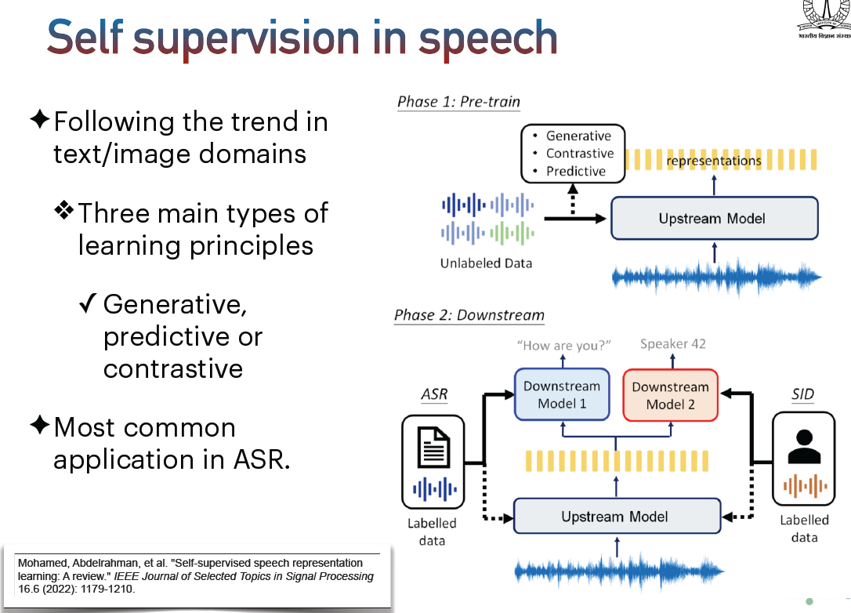

Fig 1c. Figure below shows a traditional figure of ASR framework. Note the use of extra information within each block to highlight specific feature/characteristics/example.

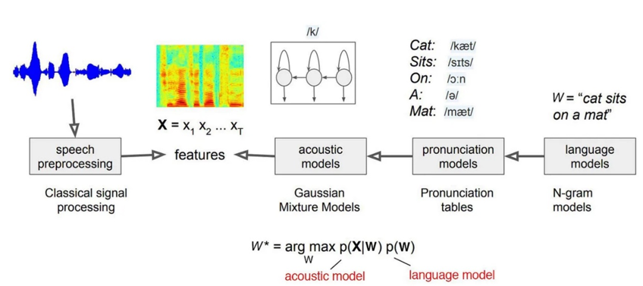

# Describing detailed techniques:

In the slides describing details of your approach, the figure should show where are your contributions within the entire architecture. E.g, by zooming into details from the big picture of the structure. You can also provide equations to illustrate cost functions and ensure equations’ names are highlighted also in the figure.

**Jia Qi: Explain the concept of Zooming In: “**In the detailed architecture images, you already have an interested reader, so you should reward them with more details of the contribution but without overwhelming them. If models are very complicated, it would be good to separate the figure for the architecture from the figure for the mechanism. I think the concept of "zooming in" with increasing levels of details is important. It is an important principle of designing both presentations and figures for papers. Rookie mistake is to just blast the reader with all the details and confuse them. I would also describe it as scaffolding the knowledge, because most of the time the reader/listener is not an expert in what you are talking about.”

Fig 2a: showing overview and zomming into each module is necessary to illustrate where the module is in overall architecture. See the green, purple and pink hierarchy below of each block!

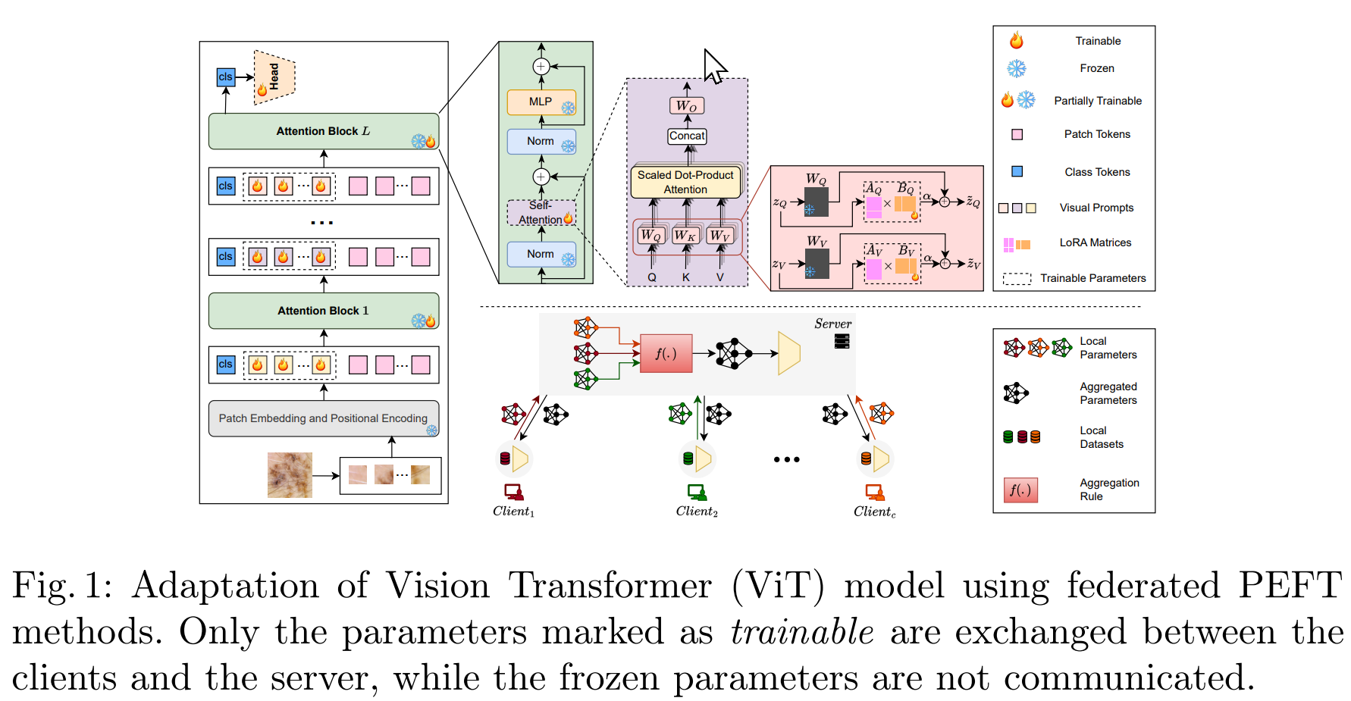

Fig 2b. Figure below shows LORA adaptation between transformer layers. To help guide the read, we use the figure on the left to show first the entire transformer architecture, and then show where is the adaptor (yellow box) follow by zooming into what LORA is as a figure and its corresponding equation. The equation’s notation much match the figure (notations). Note, the other things must be there: figure title, and citations.

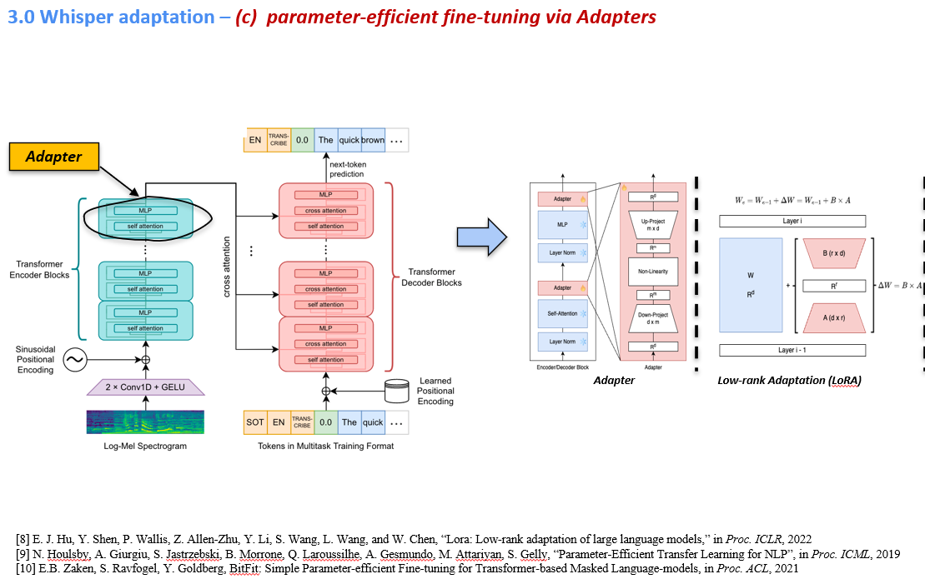

Fig 2c. Below is another example showing links between equations and figure illustrating proposed architecture. In the second slide showing the maths, equations and descriptions are kept to minimum. Importantly the equations notations are highlighted in the figure.

Key information: citations of paper included, color coding allows reader to distinguish different branches, circle illustrate cost function, notations are introduced in figure which corresponds to paper and equation introduced.

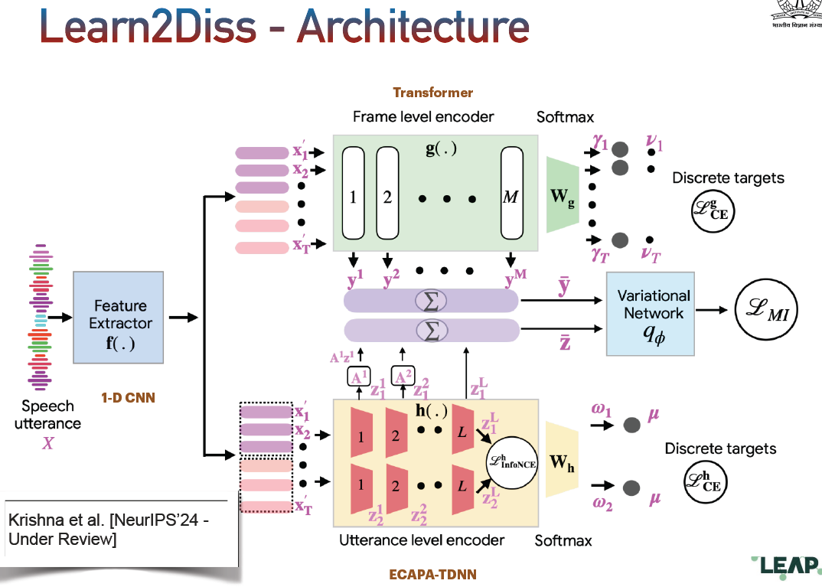

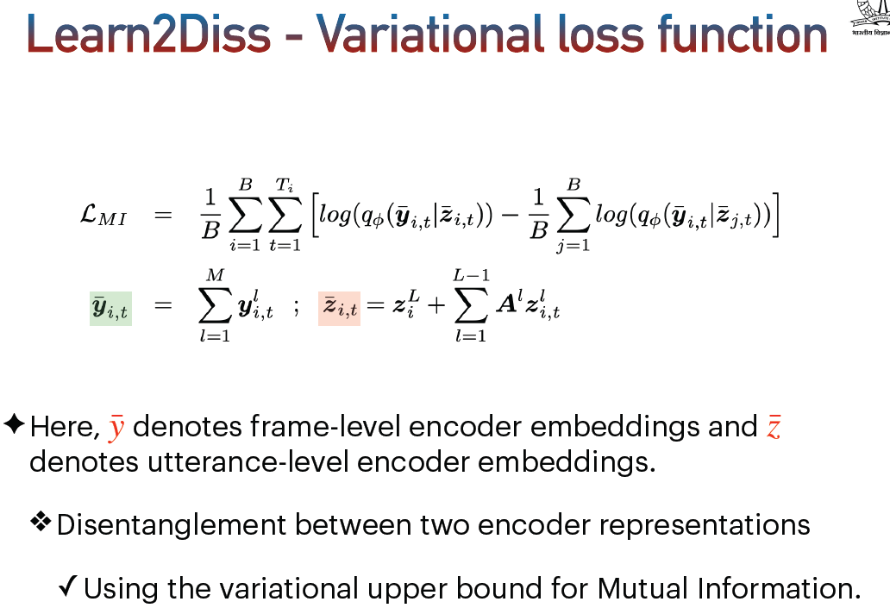

Fig 2d: comparing 3 different approaches with pipeline to illustrate differences.

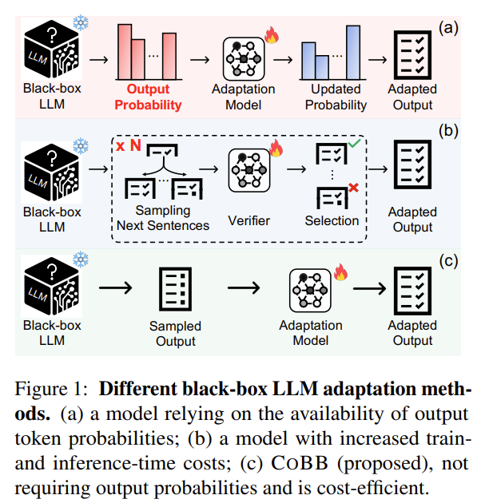

Fig 2e: overviewing related techniques om a framework: see bottom left (different task embeddings) into the framework. LORA in the second column. Key idea: illustrate using different colors for different tasks.

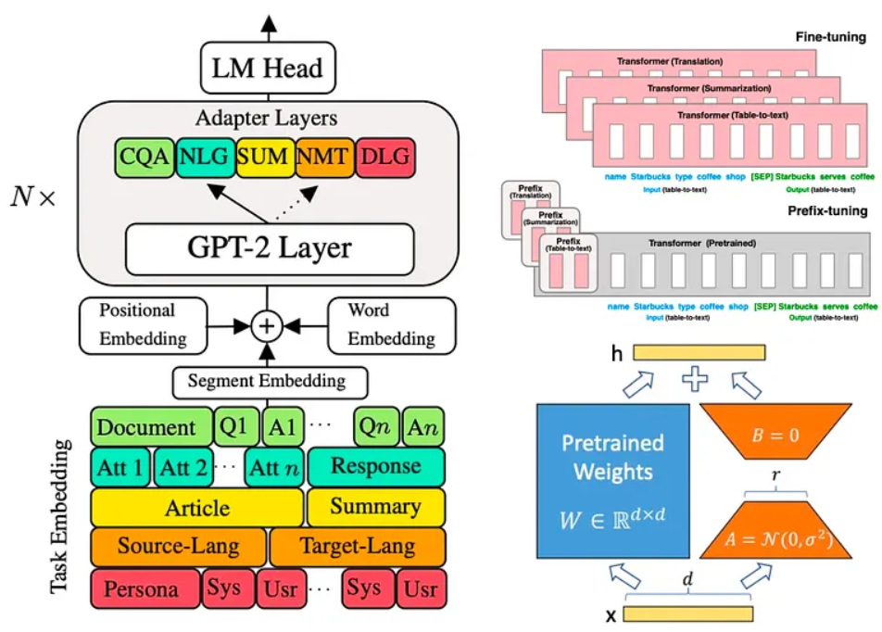

# Slide overviewing literature survey

In every PhD QE or defense, there should be a detailed overview of past works. Importantly, the slides should show how past works are related to your current thesis focus. Here we show you different styles of lit survey slides you can use.

3a) Chronological vs performance and approaches

3b) Table of details show name of model, date, etc (the etc is important)!

3c) Tree showing how each technique (leaf) is related vs time

3d) A more detailed tree may be required.

3e) Detailed chronological evolution of ChatGPT showing year, techniques changed, and name.

3f) Comparisons of techniques by figure showing how PEFT is integrated within transformer.

3fii) A detailed breakdown of PEFT methods

3g) Nice overview of TTS approaches with respect to different representations, approaches, chronological,examples

Fig 3a) Chronological vs performance and approaches. Information included types of solving capacity, examples+names of approaches vs time.

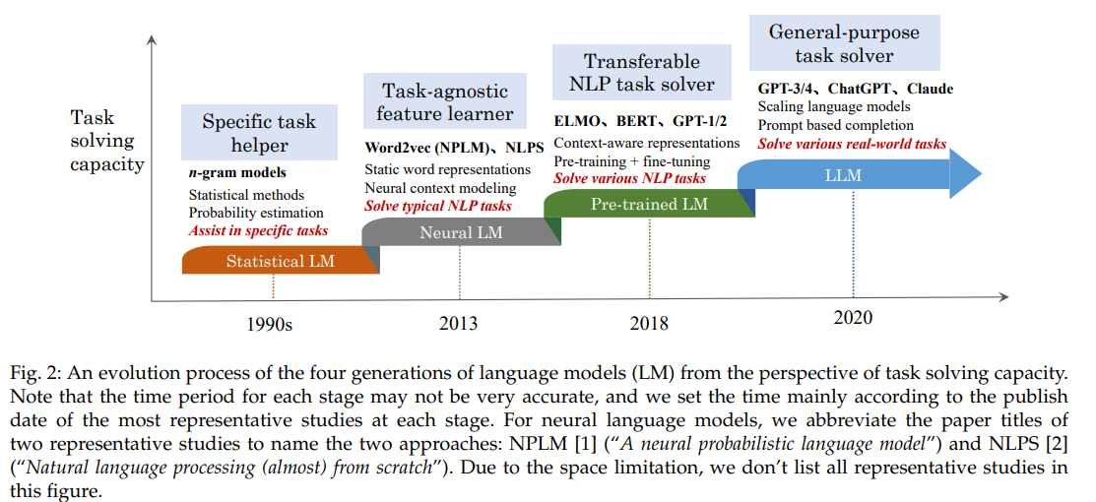

Source = <https://arxiv.org/pdf/2303.18223>

Fig 3b) Table of details show name of model, date, etc (the etc is important)

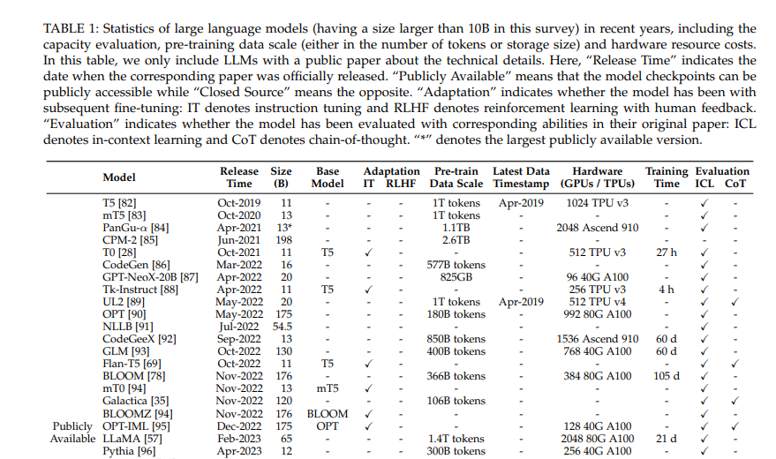

Fig 3c) Tree figure approach with branches and leaves showing how each approach are related, and the vertical axis is time. Extra information such as open/close sourced is highlighted by shaded/unshaded boxes. Color coding branches ease visualization of different classes of approaches.

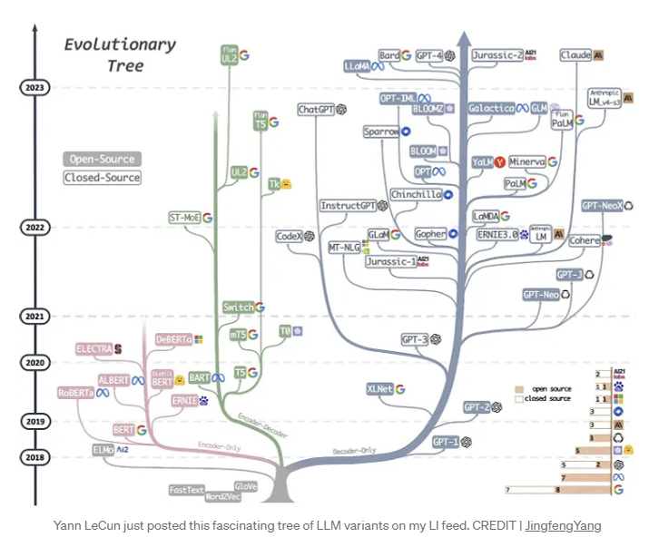

Fig 3d) A more detailed tree may be required. You can consider zooming into a branch with more

Information, e.g, Llama’s LLM evolution expanded below.

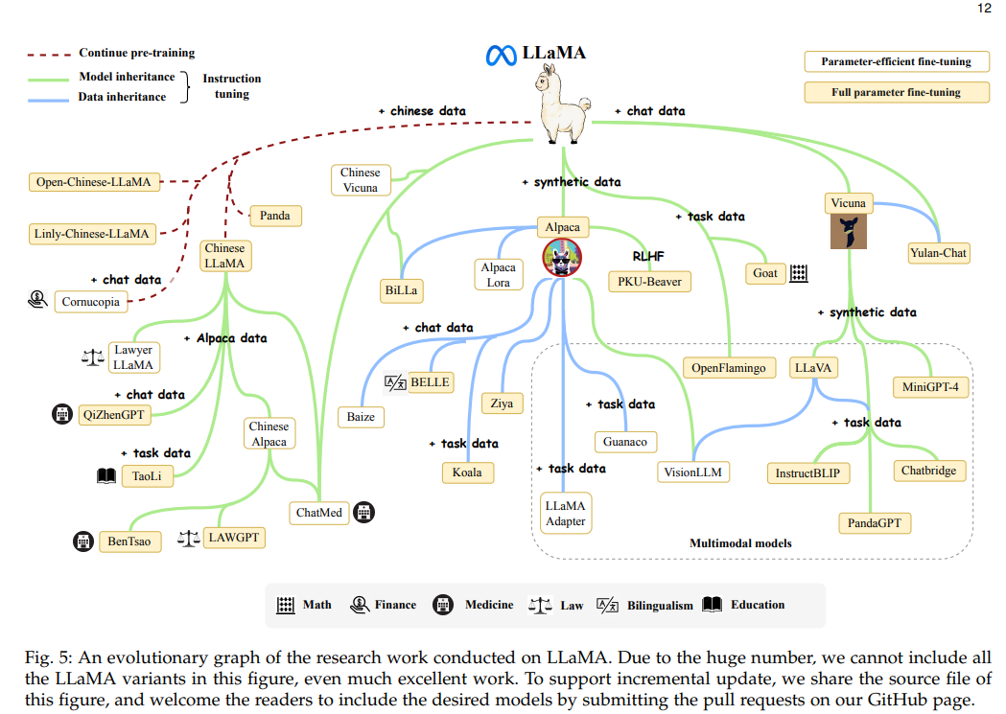

Fig 3e) Figure below shows detailed chronological evolution of ChatGPT showing year, techniques changed, and name. Important information of time, name of models, type of approach to realized models are included within each block.

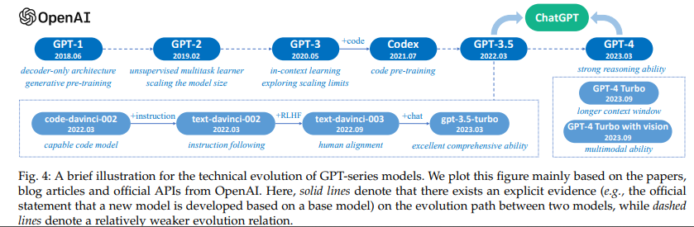

Fig 3f) Comparisons of techniques by figure showing how PEFT is integrated within transformer.

Each approach of PEFT illustrated using the same level of detail which allow reader to compare across techniques seamlessly. The highlighted block shows the key idea of each approach, and extra descriptions below provide supporting details. The inclusion of citations is required.

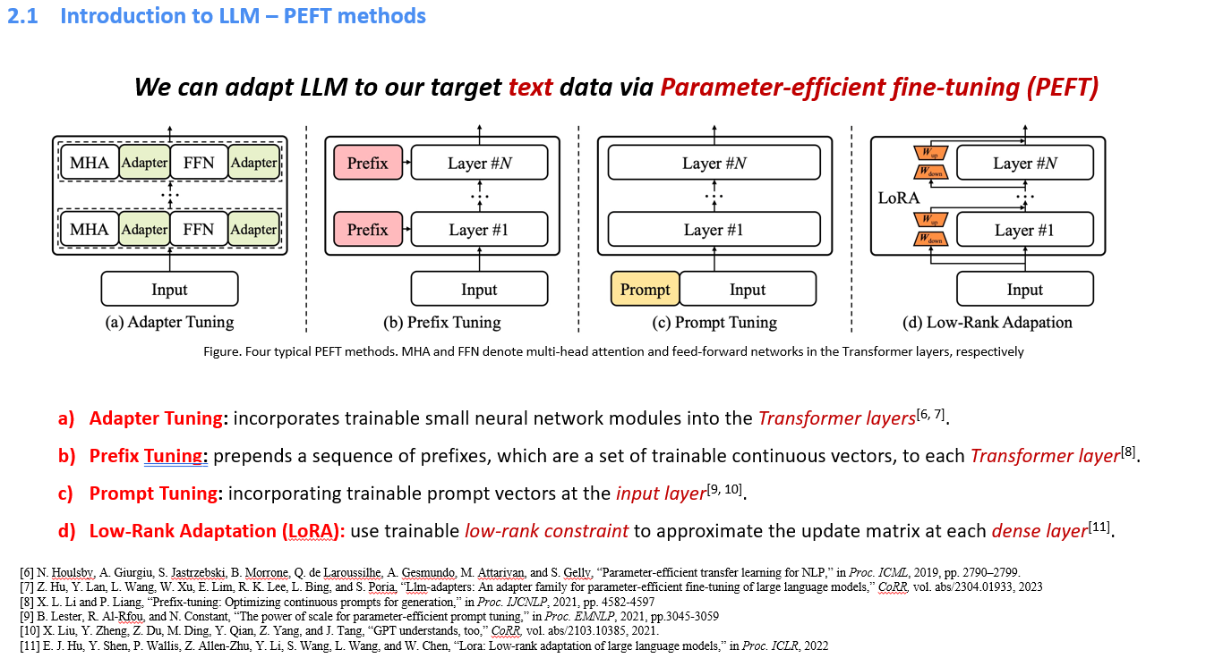

Fig 3fii) Two detailed PEFT methods breakdown from ([2403.14608](https://arxiv.org/pdf/2403.14608)), [2410.19878v1](https://arxiv.org/pdf/2410.19878v1)

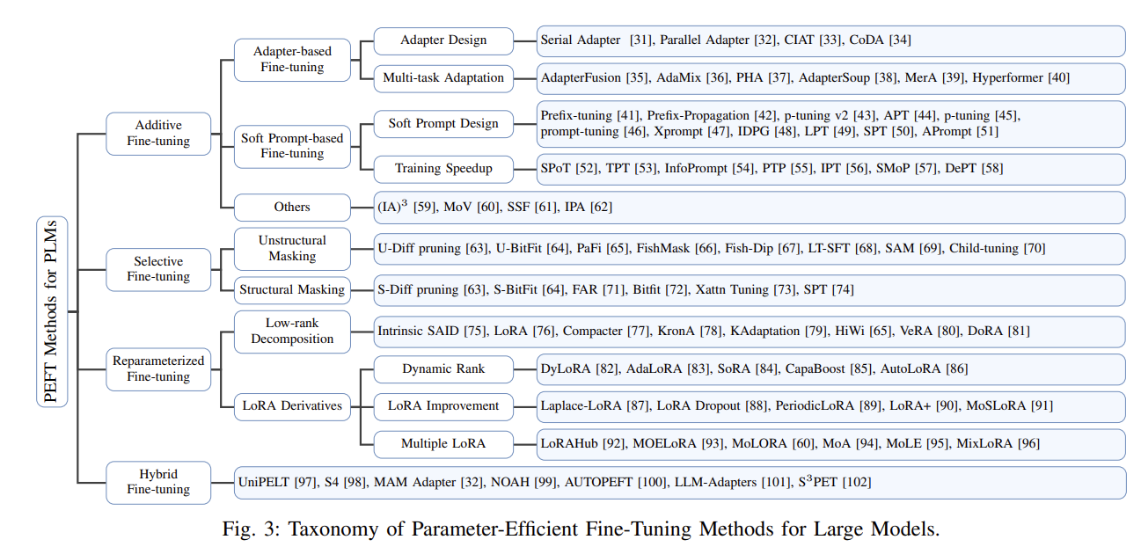

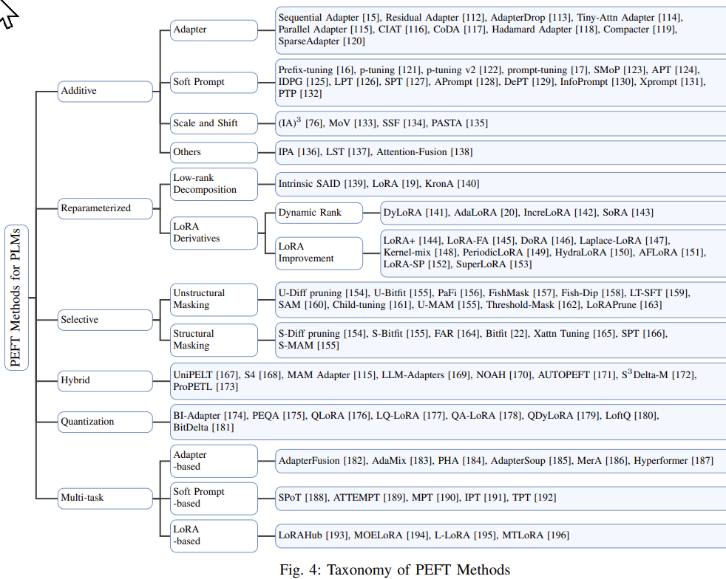

3g) Nice overview of TTS approaches with respect to different representations, approaches,

chronological,examples

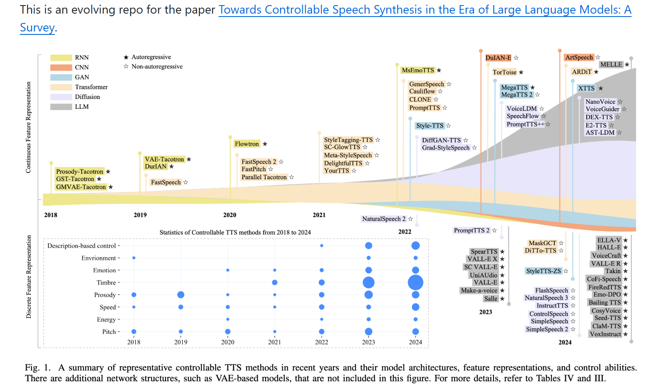

# Comparison of results

In every PhD QE or defense, you should have abalation studies comparing past works. Here we show you different styles of lit survey slides you can use. Here are some examples:

4a) A table comparing SOTA against yours.

4b) Experimental results visualizing why your method works

Fig 4a) A table comparing state of the art results against yours. Divisions along vertical axis breaks down approaches by classes, highlighted row shows your approach, columns show important measures to consider performance, etc. Some remarks below for takeaways.

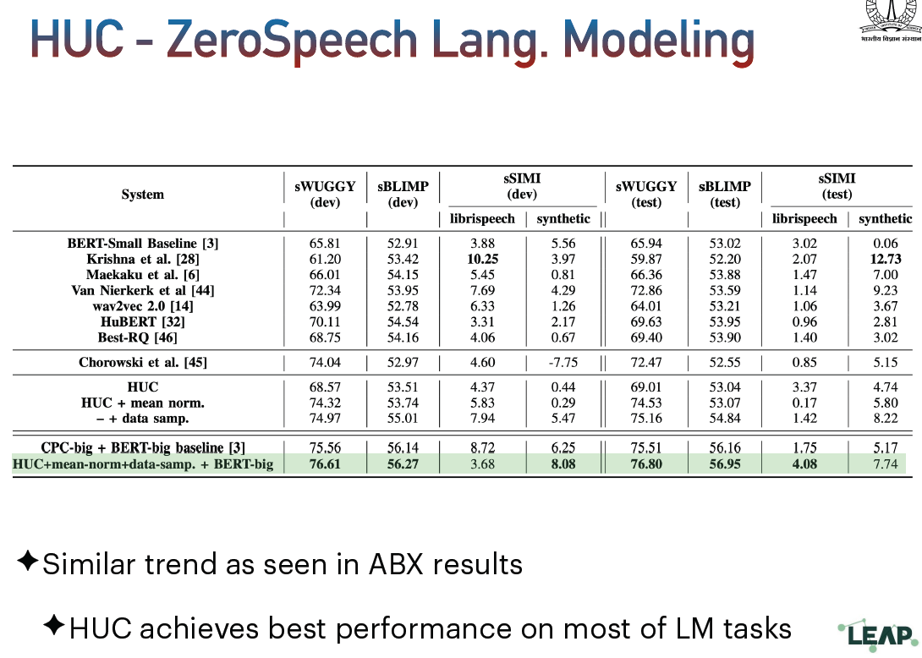

Fig 4b) Some figures to support why your method works

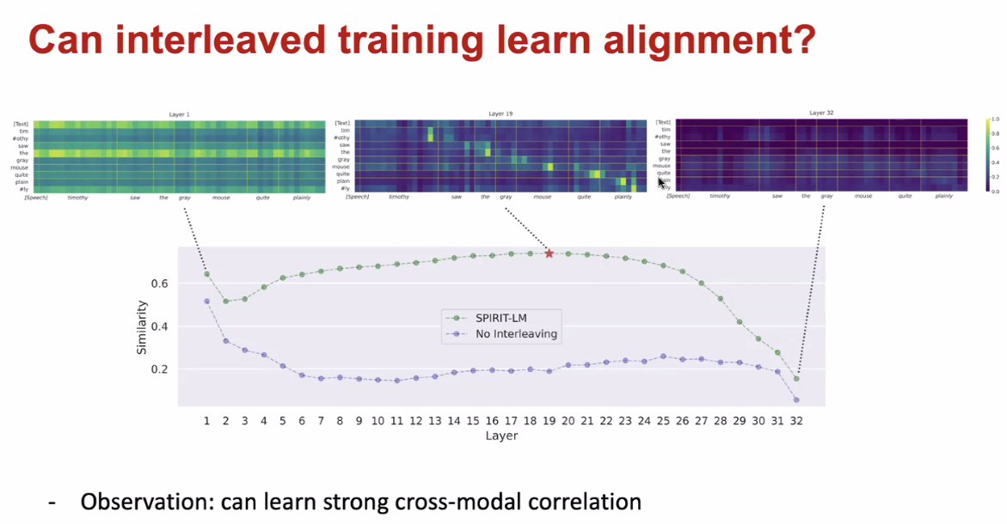

4C) A figure to illustrate the setup of the experiment and the experimental results (Takuya Fujimura)

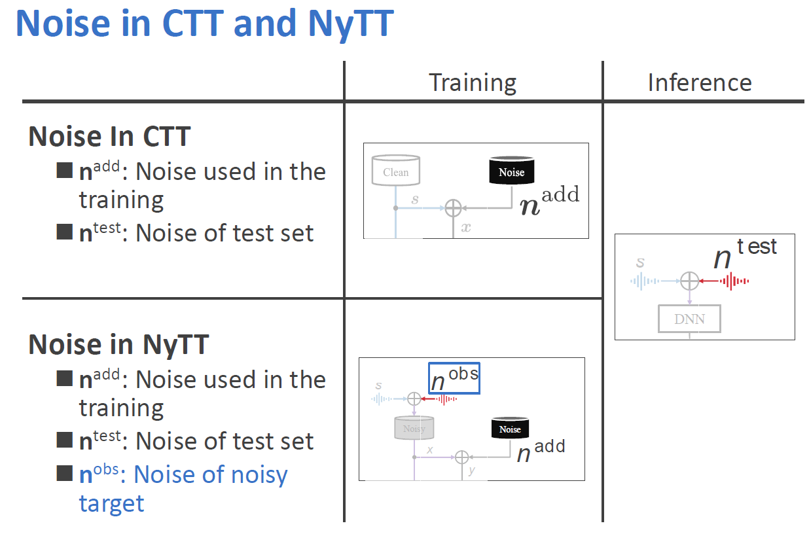

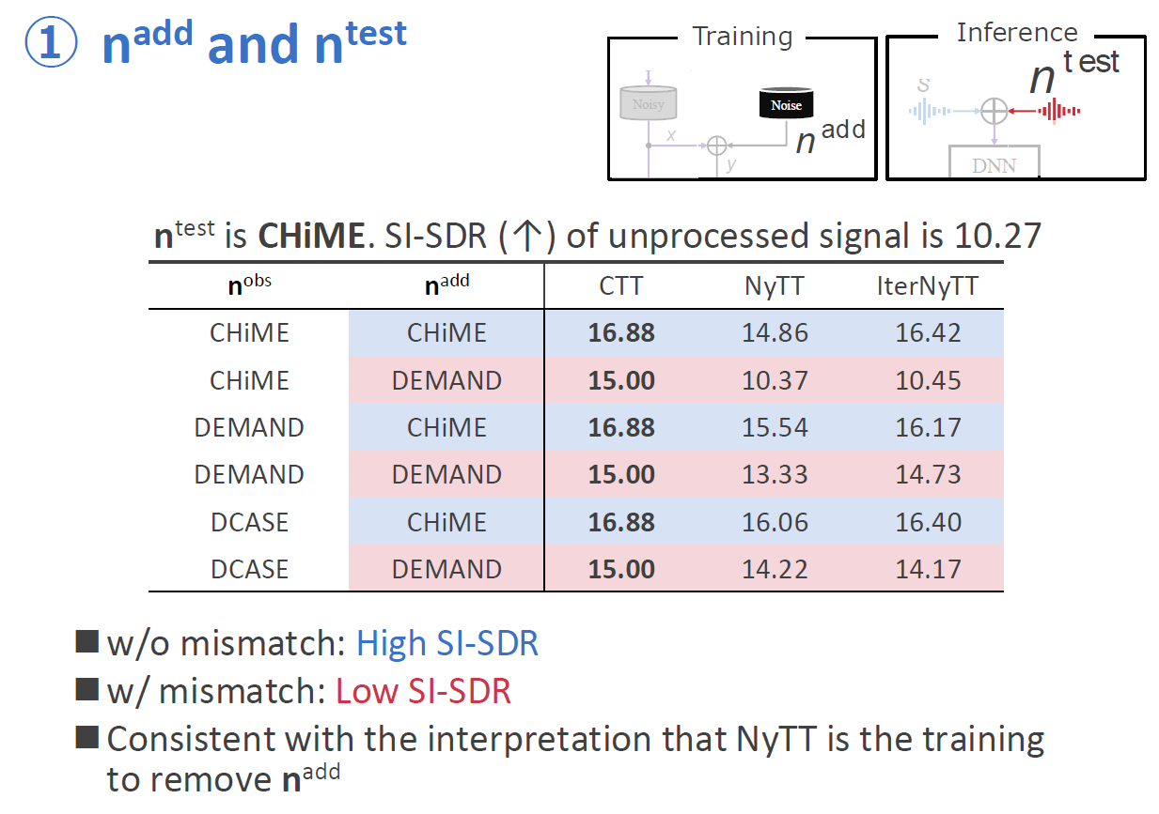

4D) Clear indication of which line if proposed, vs others

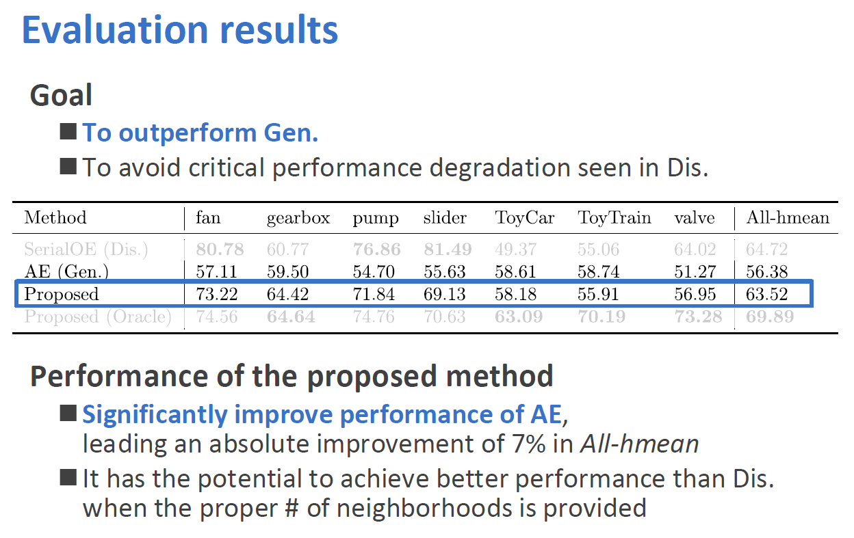

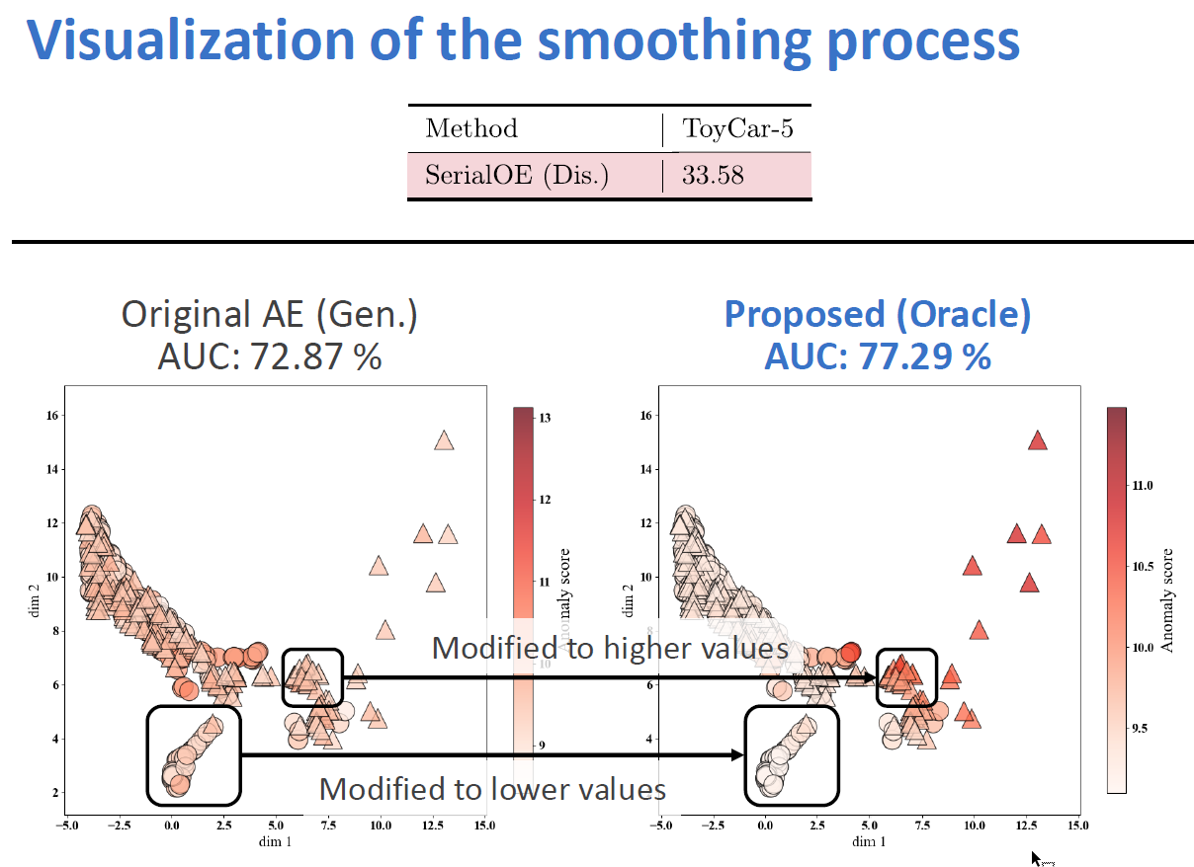

# Introducing your Pipeline

If you have a long process from input to output, this is a pipeline. You should have a figure to illustrate this. Information about the purpose of each block, the type/example of inputs, the direction of the pipeline should be shown. Some examples below

5a. Text processing example

5b. Diarization pipeline

5c. Signal processing example

5a) Text processing example, showing each block and purpose with example.

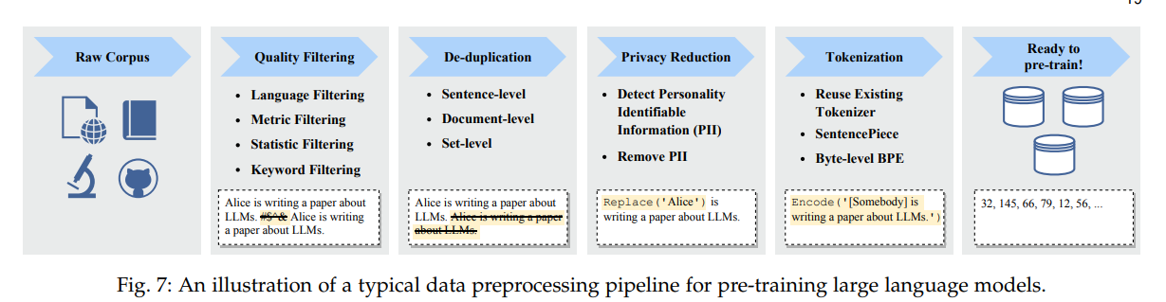

5b) A diarization pipeline

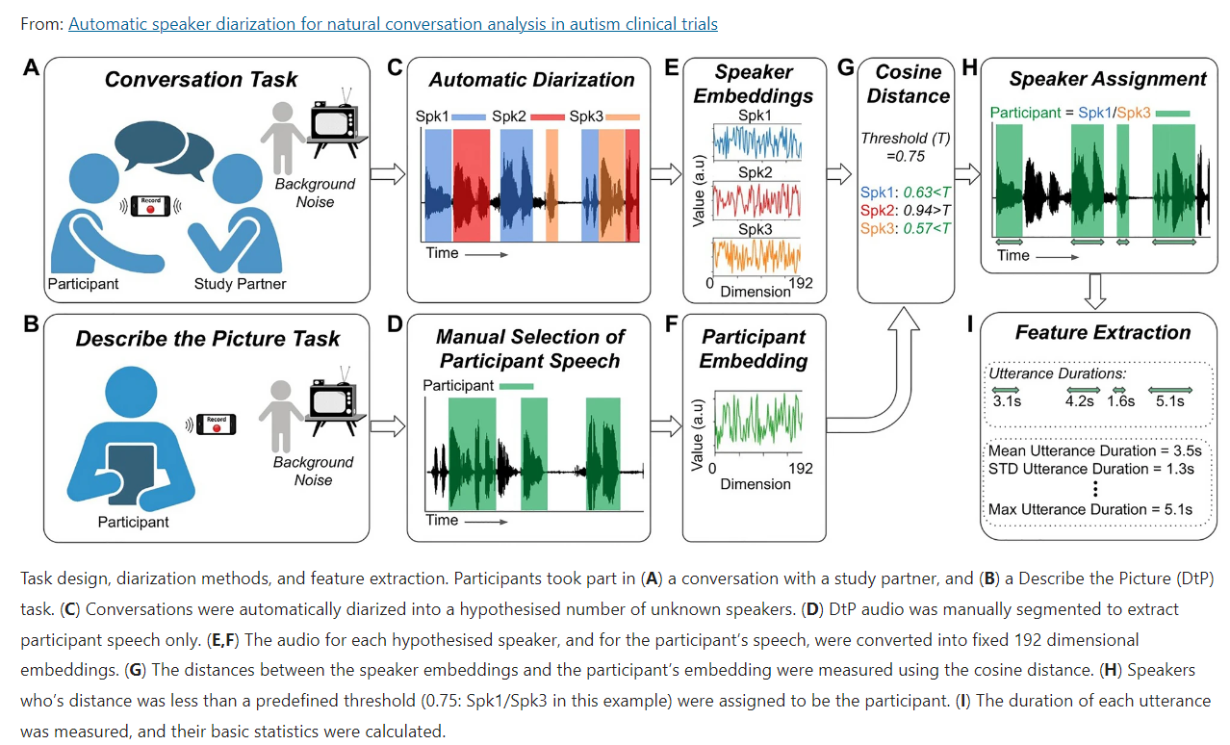

5c) Signal processing example, showing how speech is converted to MFCC features with intermediate information included.

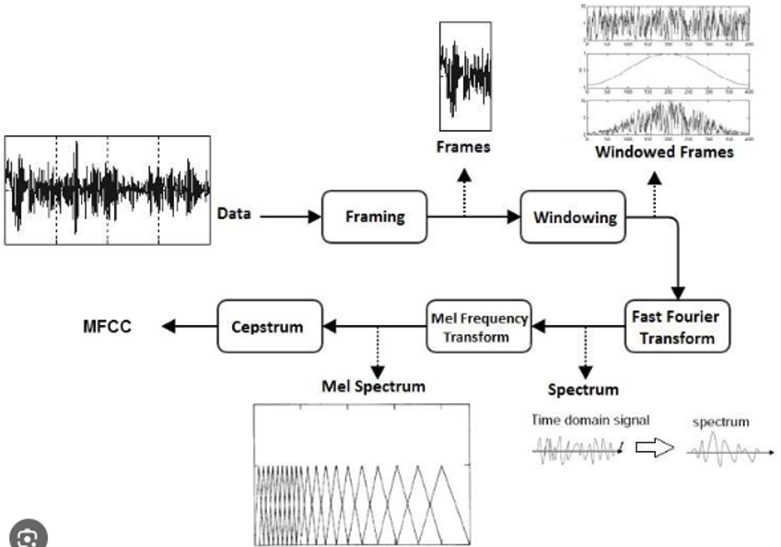

# Text only slides

Words only slides -> should have a title, and only use point forms with indentations, and with citations as required.

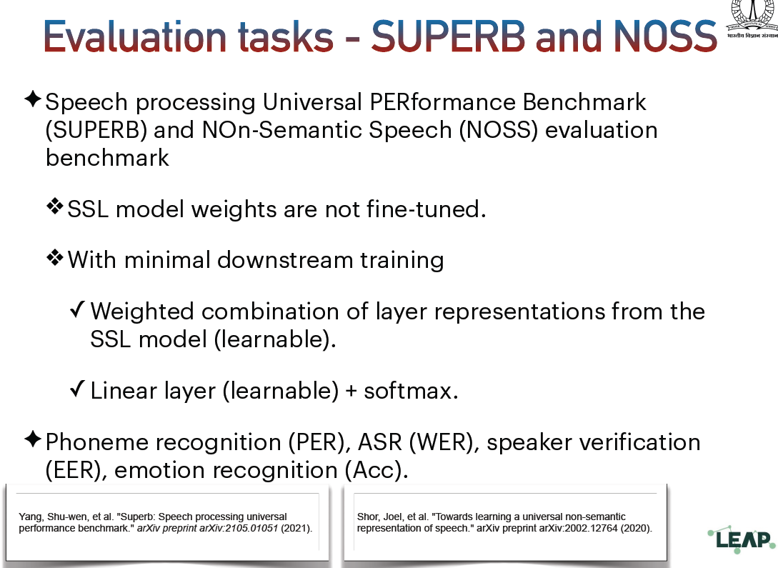

# Introduction to problem (objective) and Future works

You will need to introduce your thesis focus. Its style is close to pipeline. A picture will be great, with title highlighting the objectives, and block diagrams with pictures highlighting the type and flow of information.

Fig 7a. Figure below introduces what the focus is about (what is interleave) pre-training.

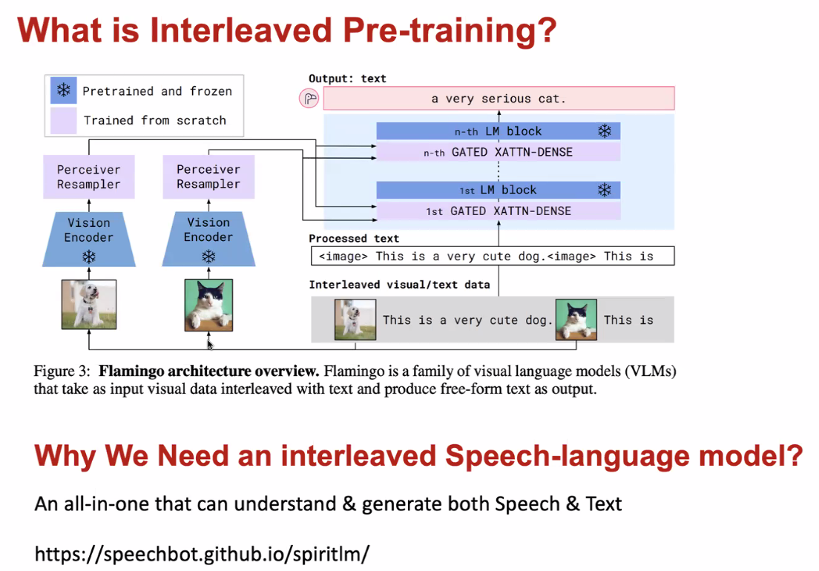

Fig 7b. Using example to show why position is all important in text embedding.

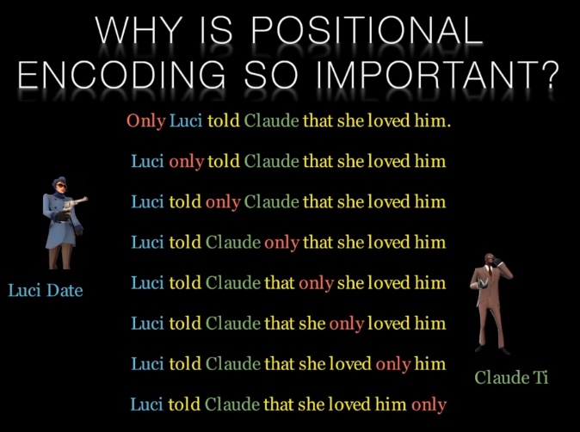

Fig 7c. When discussing future work: Use figure to comprehensively shows input and output, with highlighted block to bring attention to how proposed LLM can be integrated for different tasks.

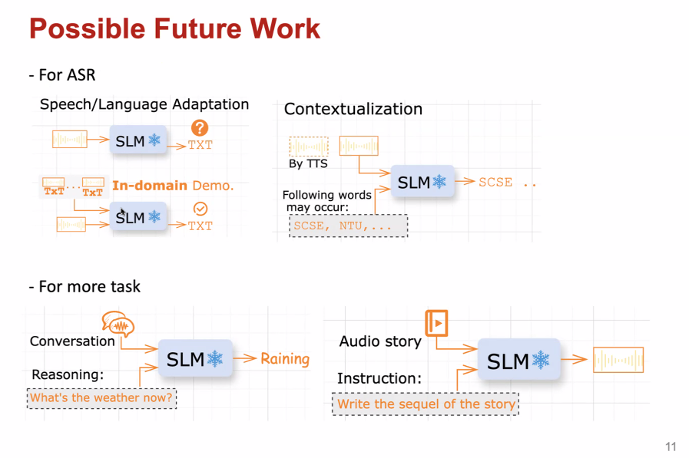

# Presenting to the team, paper review

* You need an indented presentation of information (up to 3 levels) and in each level clearly indicate WHAT you are talking about. See below by Haoyang:

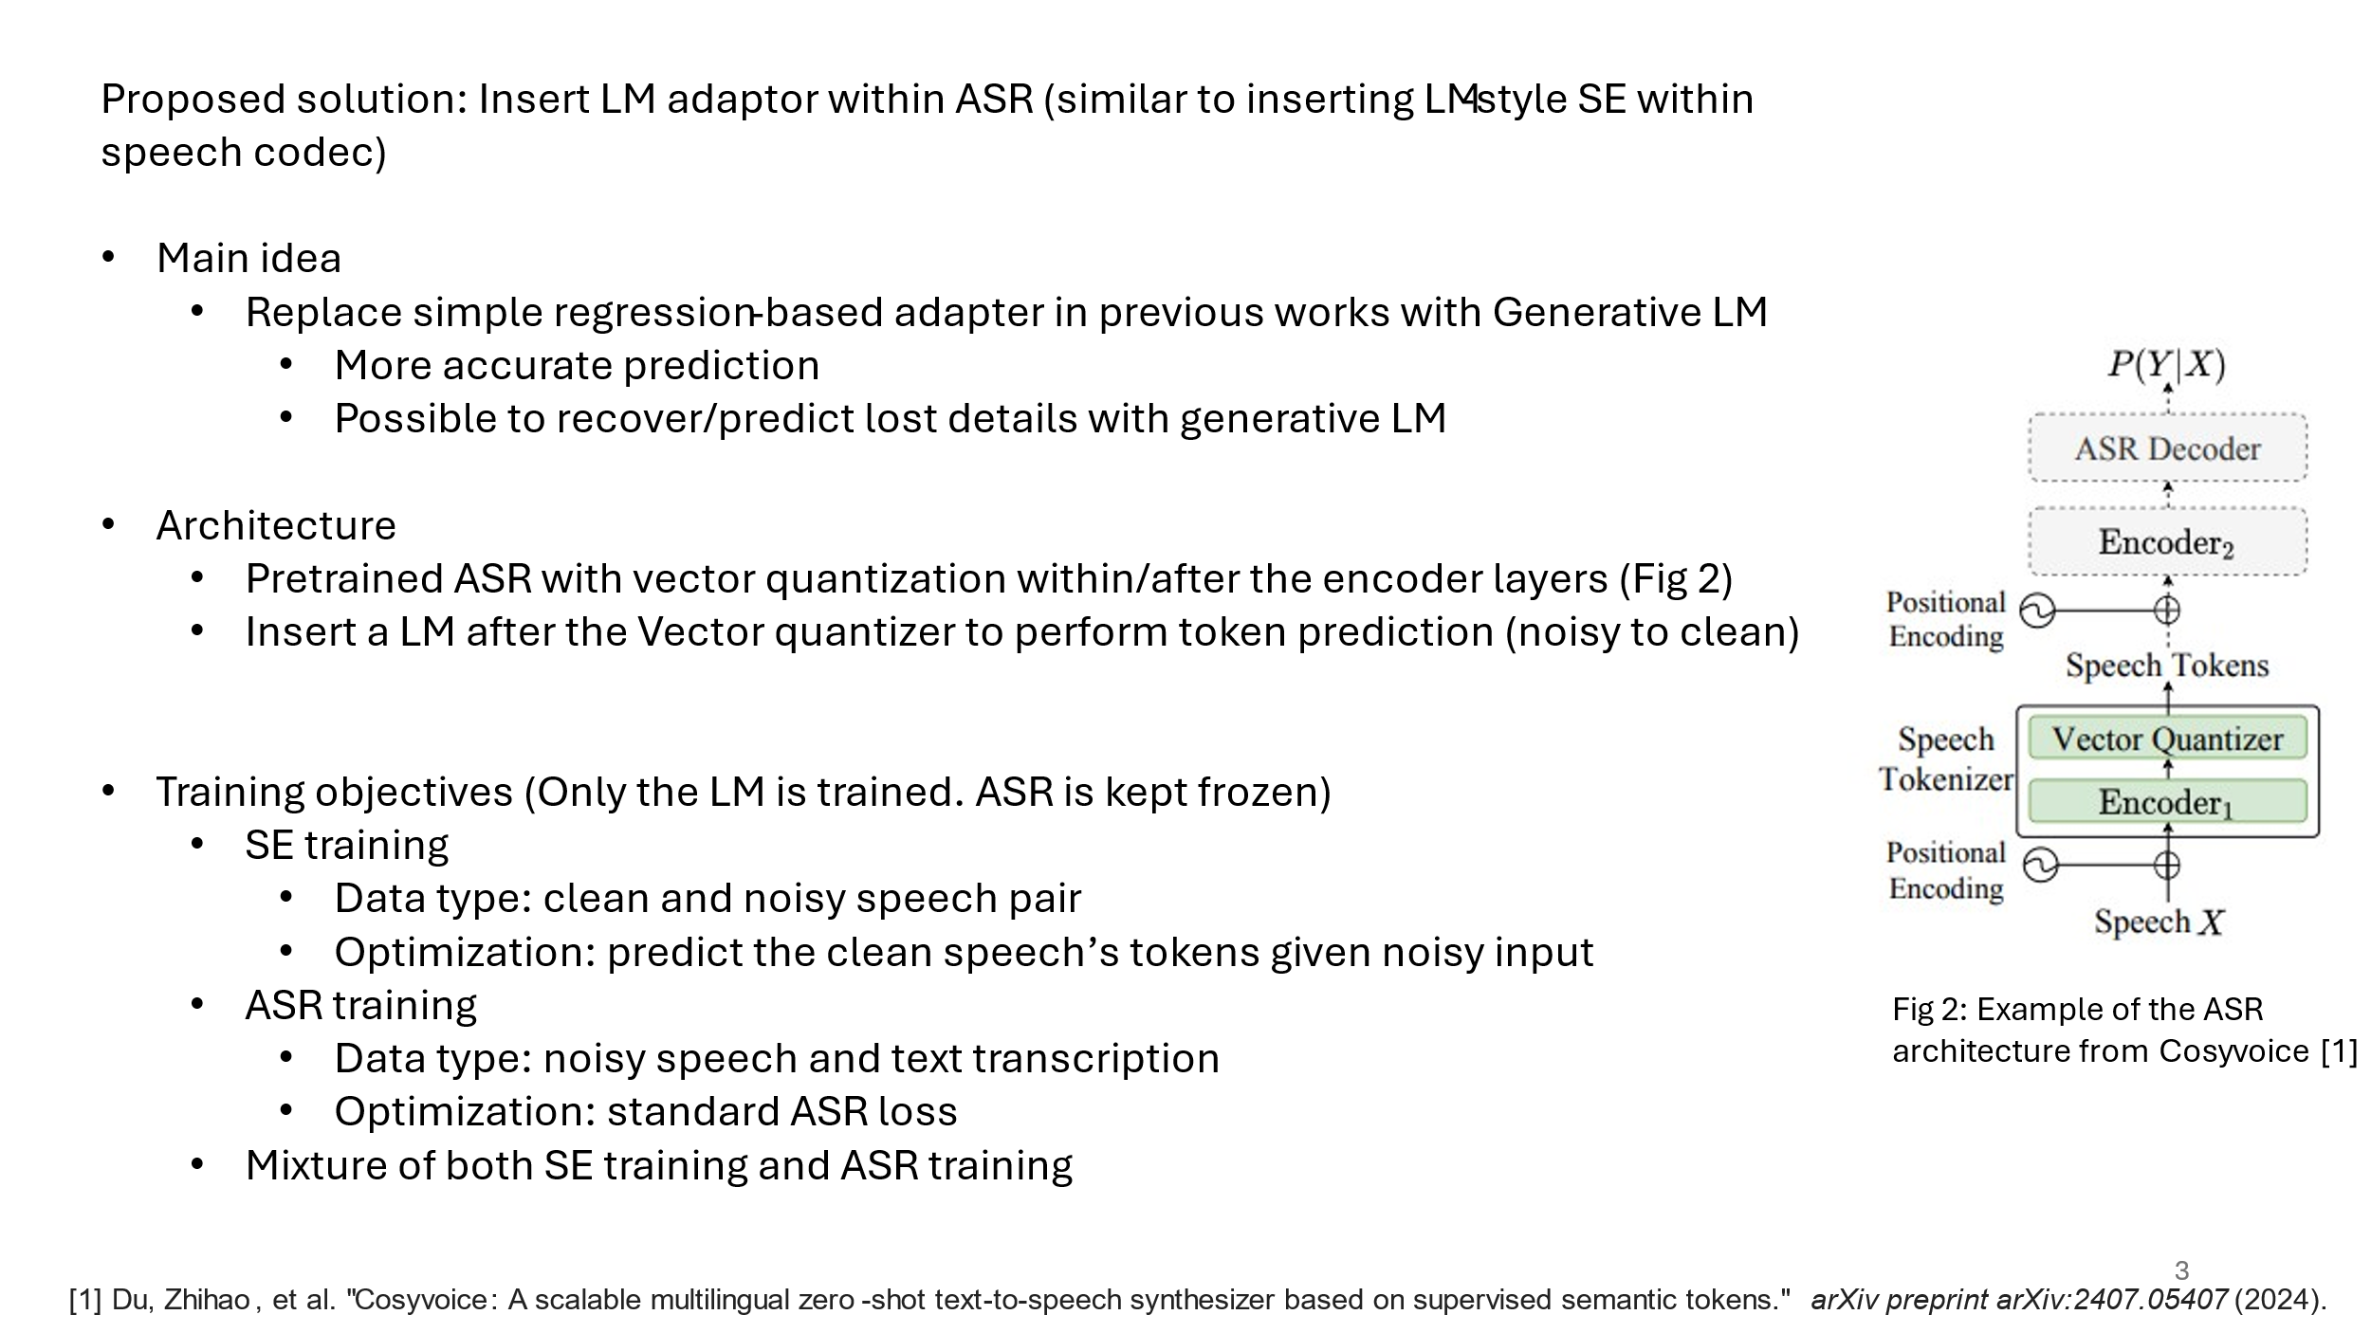

1. **Examples of posters**

Slides for poster:

* + - you must include citations of the papers and previous works,
    - Use lots of pictures, tables,

See:

following examples good:

style is ok (but this unfortunately has no ref) :

https://neurips.cc/media/PosterPDFs/NeurIPS%202024/94927.png?t=1733654849.1679301

<https://neurips.cc/media/PosterPDFs/NeurIPS%202024/96882.png?t=1731683595.700073>

<https://neurips.cc/media/PosterPDFs/NeurIPS%202023/70700.png?t=1699465553.0593388>

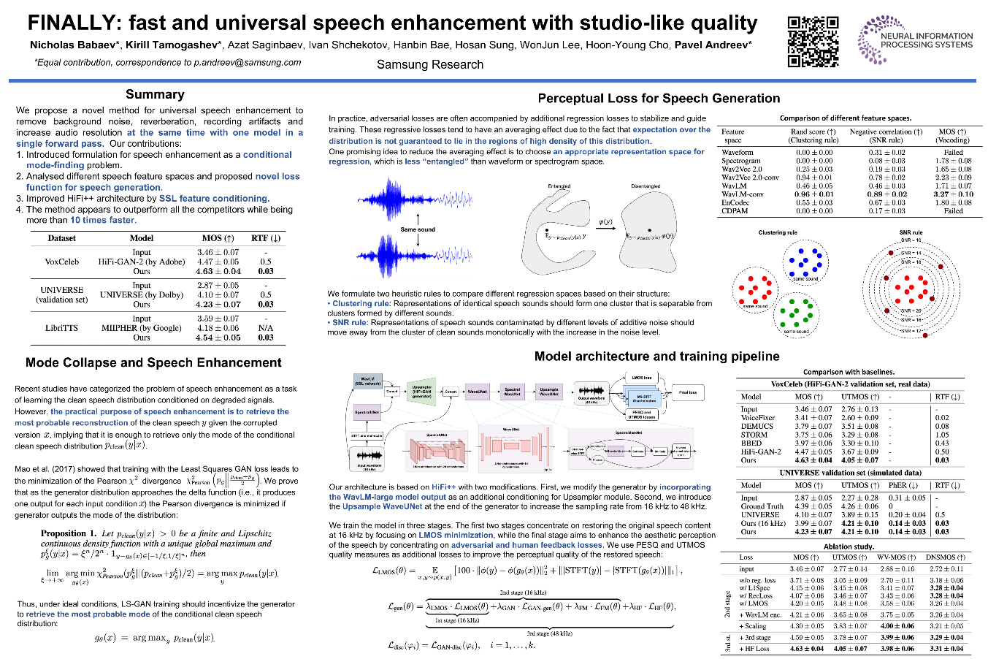

**// suggest including citations**

